**Assignment No:- 17**

**Assignment Name:- Create an ASP.NET web form having list box bounded through Array list. Allow multiple selection list box and display multiple values selected by user on a web** **page.**

**Name:-CHIRAG ASHOK MAHAJAN.**

**Roll No:- 59.**

**______________________________________________________________________________**

* **Default.aspx Page :-**

<%@ Page Language="C#" AutoEventWireup="true" CodeFile="Default.aspx.cs" Inherits="_Default" %>

<!DOCTYPE html>

<html xmlns="http://www.w3.org/1999/xhtml">

<head runat="server">

<title></title>

</head>

<body>

<form id="form1" runat="server">

<div>

<asp:Label ID="Label2" runat="server" Font-Bold="True" Font-Size="Large" Text="Select Your Mulitple Skills : "></asp:Label>

<br />

<br />

<asp:ListBox ID="ListBox1" runat="server" Height="165px" SelectionMode="Multiple" Width="228px" ></asp:ListBox>

<br />

<br />

</div>

<asp:Button ID="Button1" runat="server" OnClick="Button1_Click" style="height: 29px" Text="Add Skills" Font-Bold="True" Font-Size="Medium" />

&nbsp;&nbsp;&nbsp;

<asp:Button ID="Button2" runat="server" OnClick="Button2_Click" Text="Submit" Font-Bold="True" Font-Size="Medium" />

<br />

<br />

<asp:Label ID="Label1" runat="server"></asp:Label>

</form>

</body>

</html>

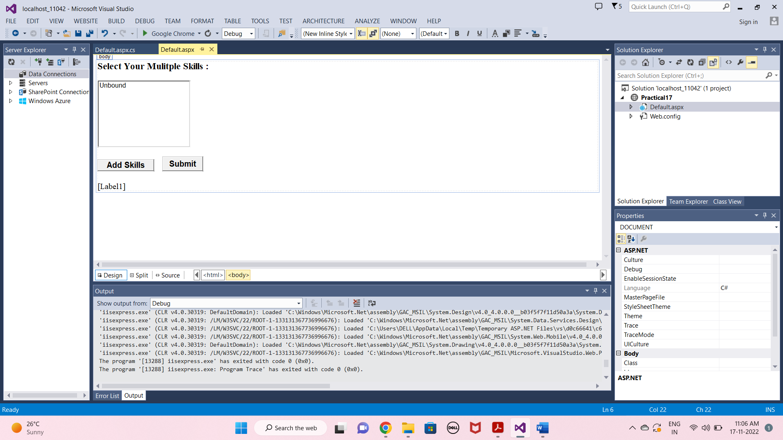

* **Default.aspx.cs Page :-**

using System;

using System.Collections.Generic;

using System.Linq;

using System.Web;

using System.Web.UI;

using System.Web.UI.WebControls;

using System.Collections;

public partial class _Default : System.Web.UI.Page

{

private ArrayList getdata()

{

ArrayList obj = new ArrayList();

obj.Add("CPP");

obj.Add("JAVA");

obj.Add("Python");

obj.Add("ASP.NET");

obj.Add("C");

obj.Add("HTML");

obj.Add("CSS");

obj.Add("AngularJS");

obj.Add("React");

return obj;

}

protected void Page_Load(object sender, EventArgs e)

{

}

protected void Button1_Click(object sender, EventArgs e)

{

ArrayList a = getdata();

ListBox1.DataSource = a;

ListBox1.DataBind();

}

protected void Button2_Click(object sender, EventArgs e)

{

Label1.Text = "";

foreach(int i in ListBox1.GetSelectedIndices())

{

Label1.Text += ListBox1.Items[i].Value + " , ";

}

}

}

**OUTPUT :-**

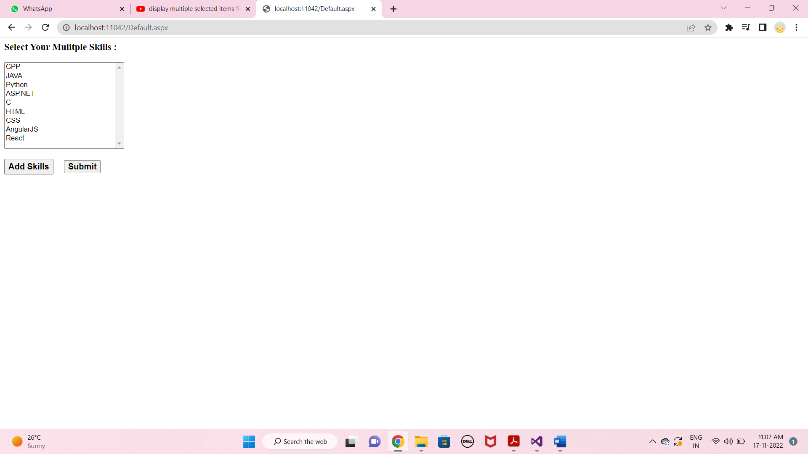

* **Select Multiple values Using ctrl button.**

